Name :Sk.Kashifa

Register no :192121135

Blood bank management system :

Activity diagram :

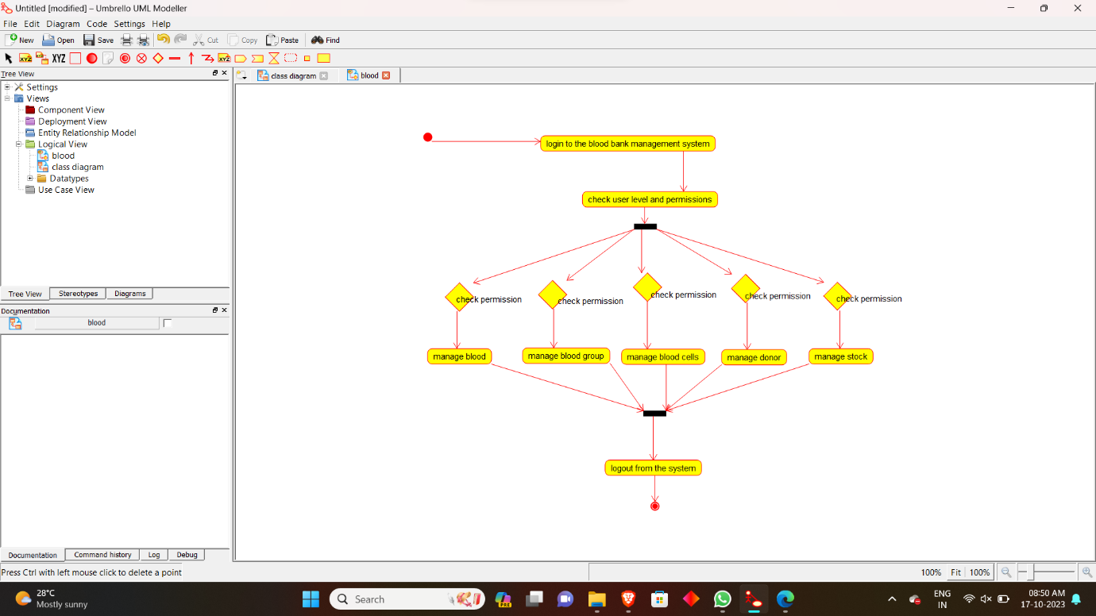

Class diagram :

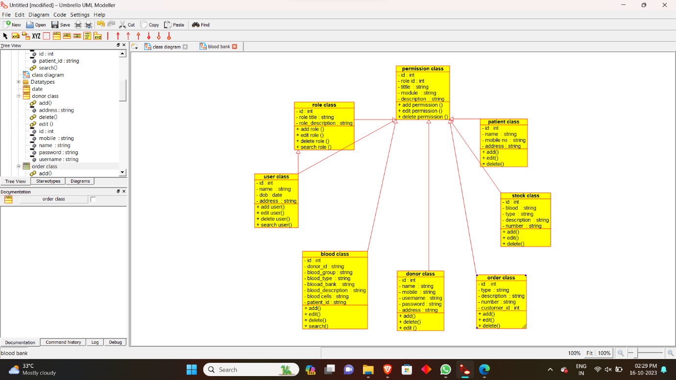

Sequence diagram :

